CIS 4911 – Senior Project
Tractouch's iBLESS
User Manual

Team Members: Luis Miguel Carrillo
Mentor: Jaime Borras
04/26/2015
COPYRIGHTS AND TRADEMARK INFORMATION

This work is entirely done by Luis Miguel Carrillo unless written otherwise.

Enter User Management

Inside login, provide the username or e-mail along the password and press enter or click login. After doing that the following screen will be shown.

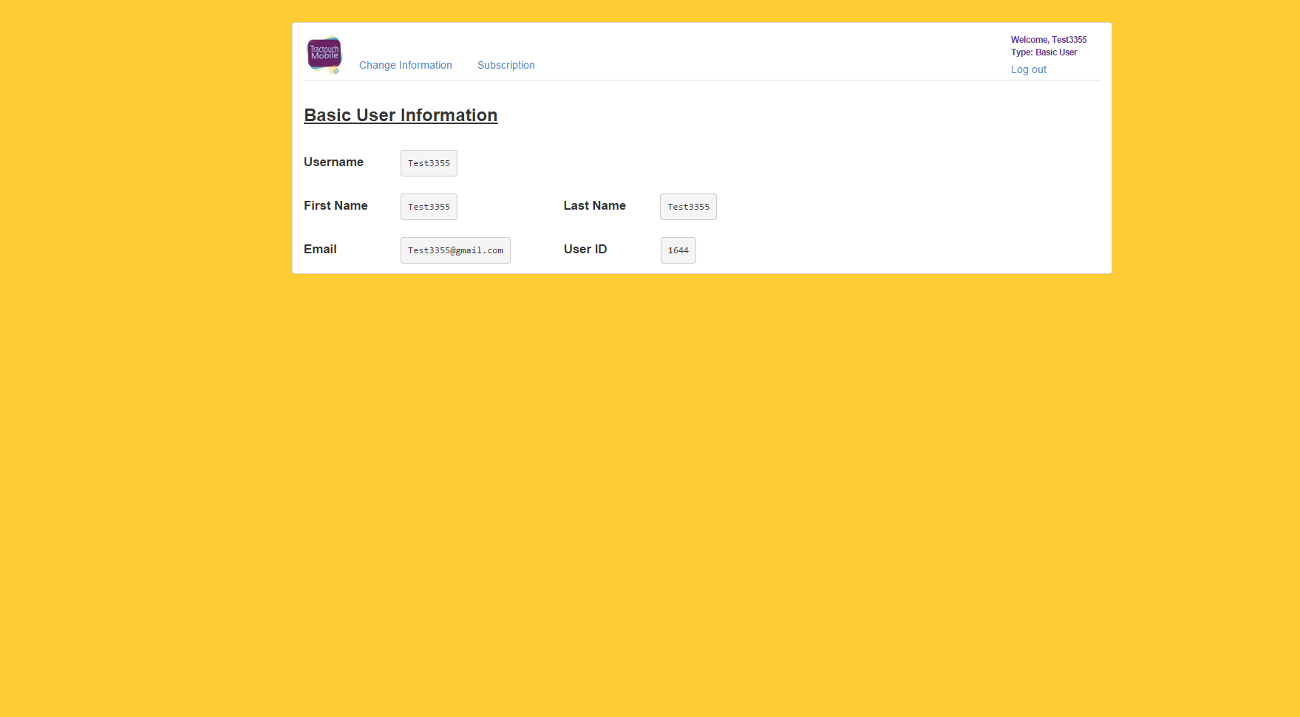
Change Information

Click on “Change Information”. Afterward provide input for each of the fields that need to be changed.

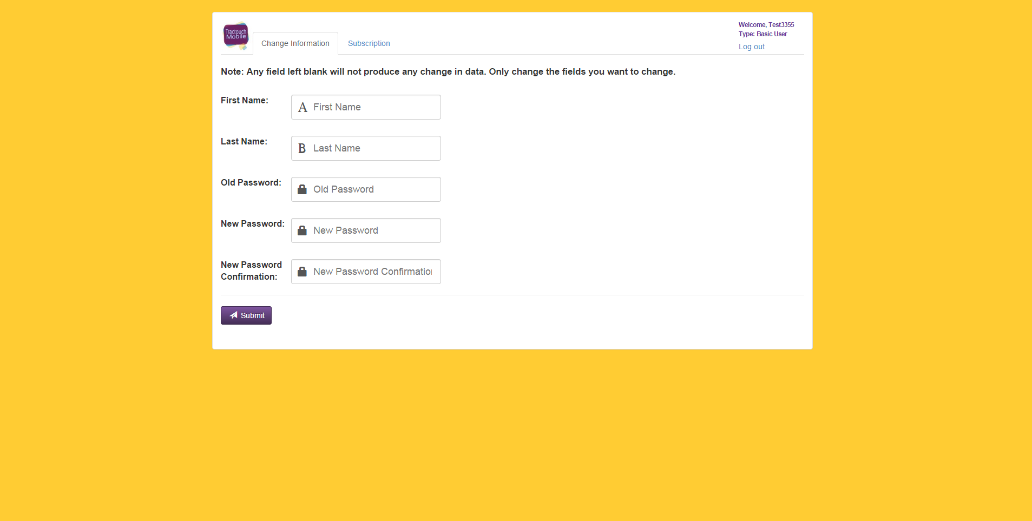

After clicking submit, a confirmation notification appears telling the user that the request was handled successfully.

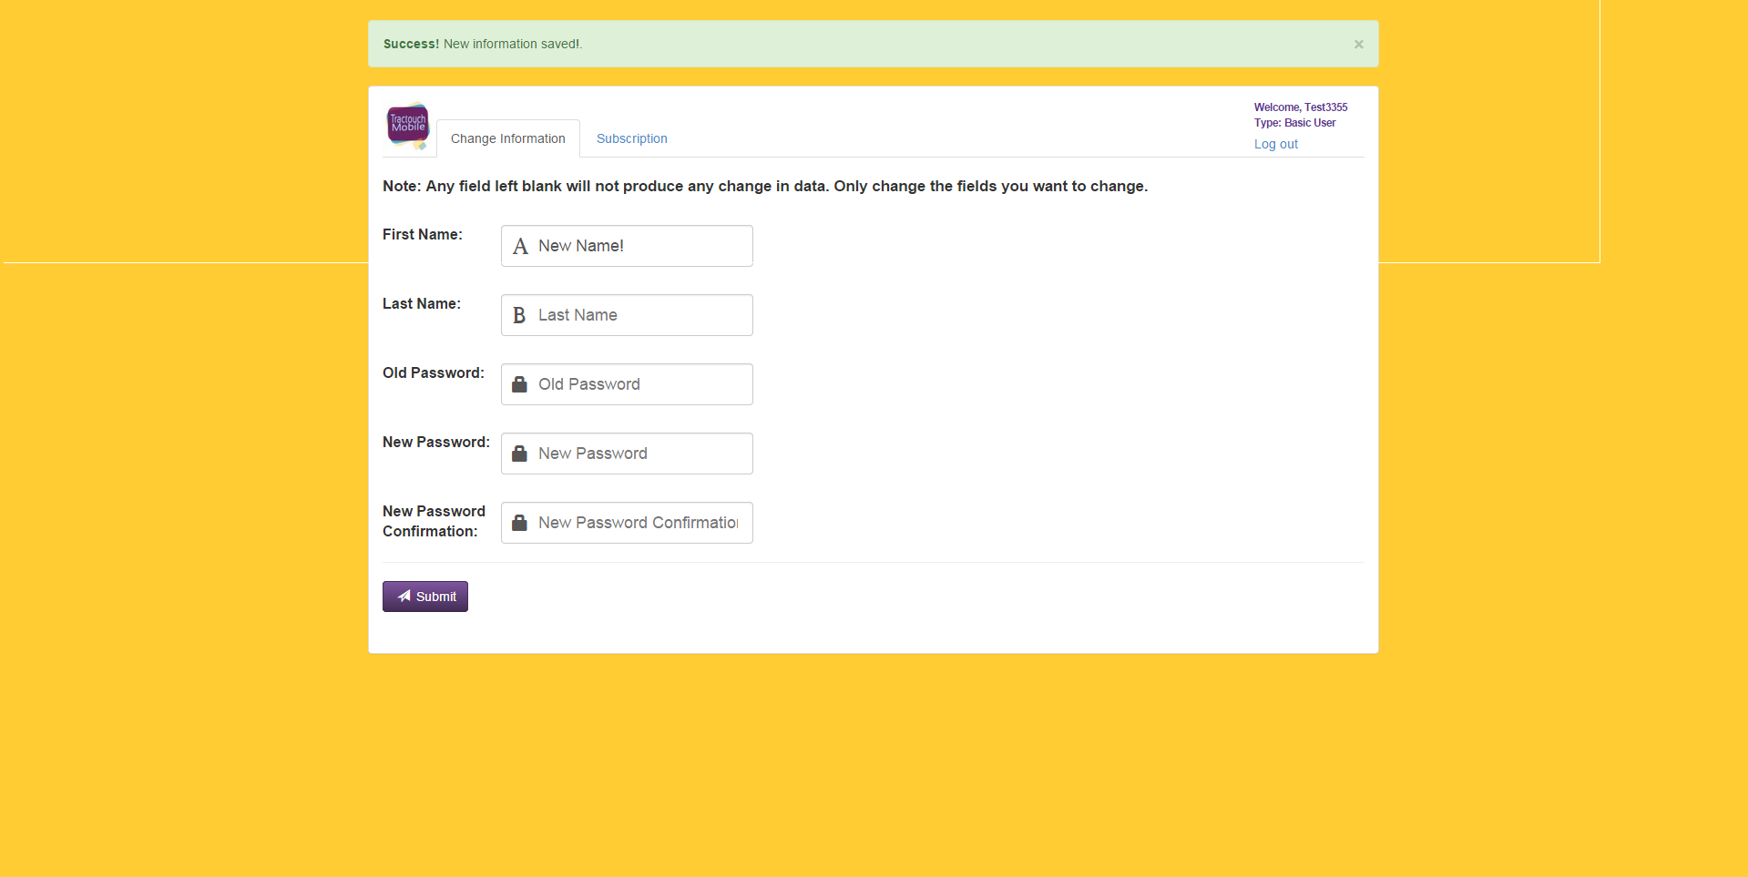
Subscribe

Click on “Subscription”, and fill out the following form

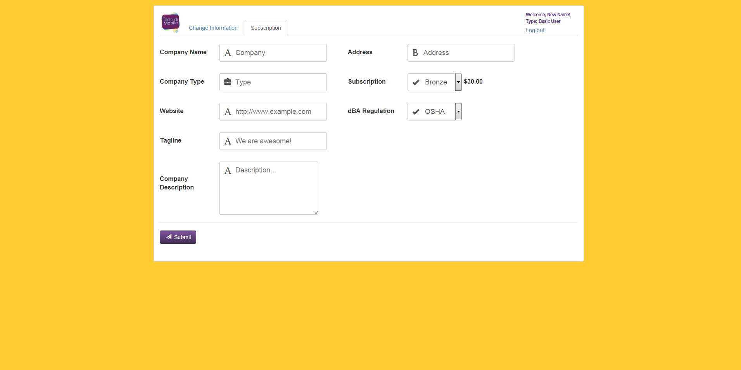

After clicking submit the user will be redirected to the payment screen.

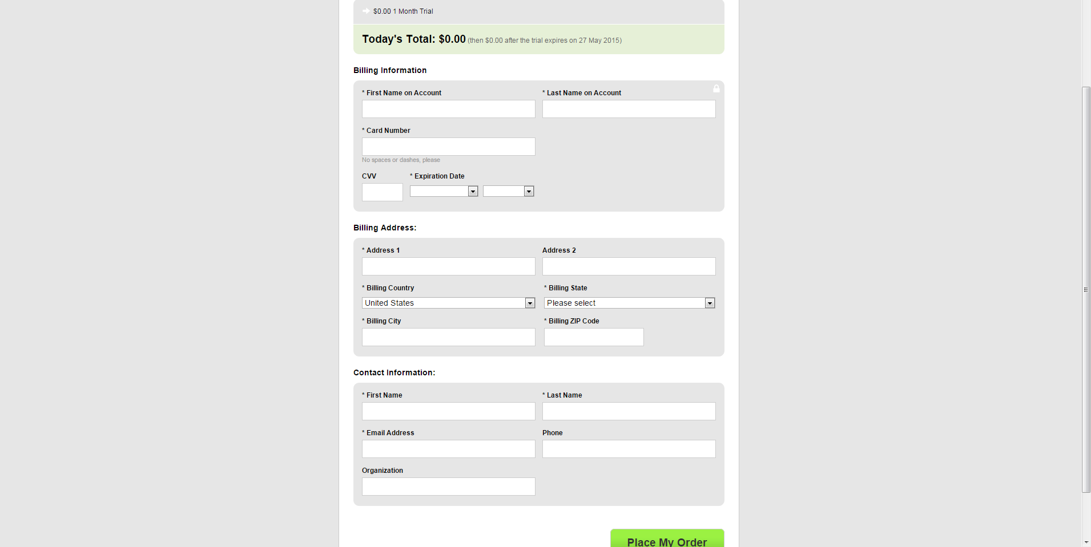
After filling all the required information, the user clicks on “Place My Order” to finalize the purchase. Afterward the system notifies the user that the account has been updated successfully.



